# **45. NAT (Dynamic): Part 2**

## **More About Static NAT**

* **Static NAT** involves statically configuring one-to-one mappings of **private IP addresses** to **public IP addresses**.
* When traffic from the **internal host** is sent to the **outside network**, the **router** will translate the **source address**.

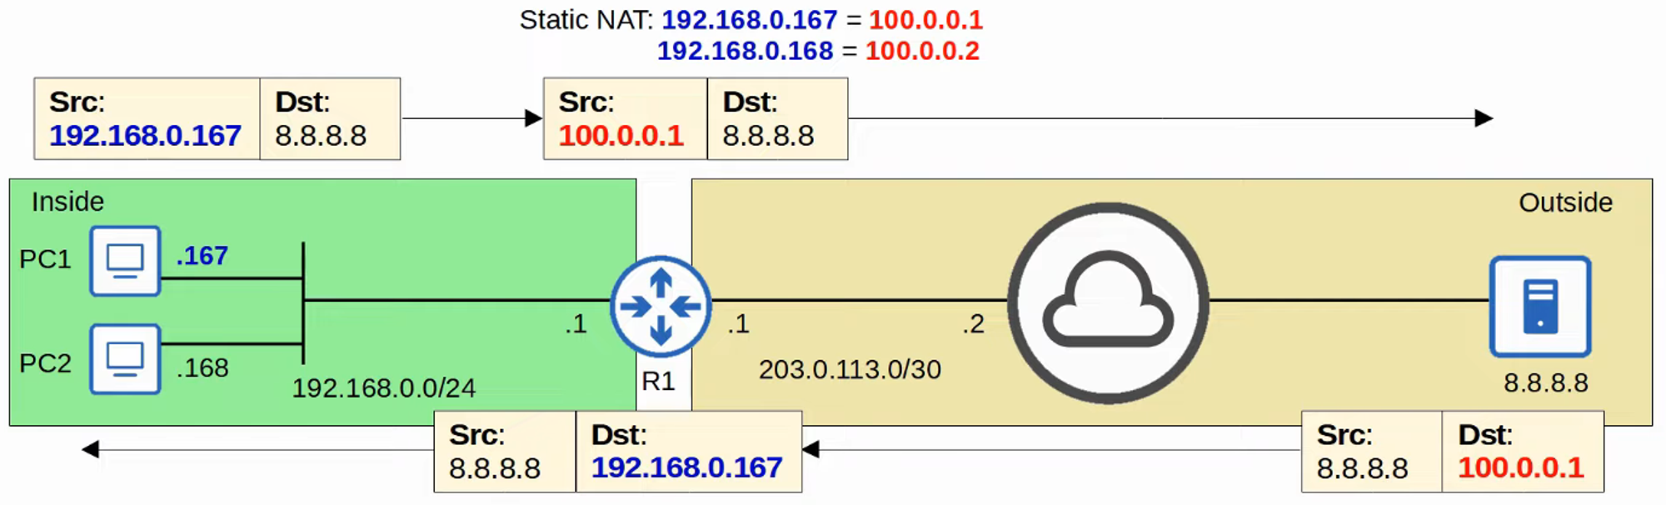

* However, this one-to-one mapping also allows **external hosts** to access the **internal host** via the **inside global address**.

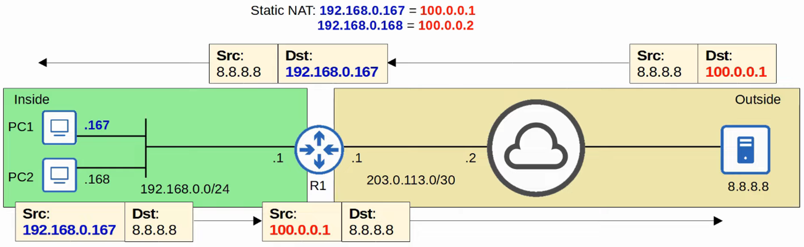

## **Dynamic NAT**

* In **Dynamic NAT**, the **router** dynamically maps **inside local addresses** to **inside global addresses** as needed.
* An **ACL** is used to identify which traffic should be translated:
  + If the **source IP is permitted**, the **source IP will be translated**.
  + If the **source IP is denied**, the **source IP will not be translated**.
  + 💡 However, **packet traffic will not be dropped**.
* A **NAT pool** is used to define the available **inside global addresses**.

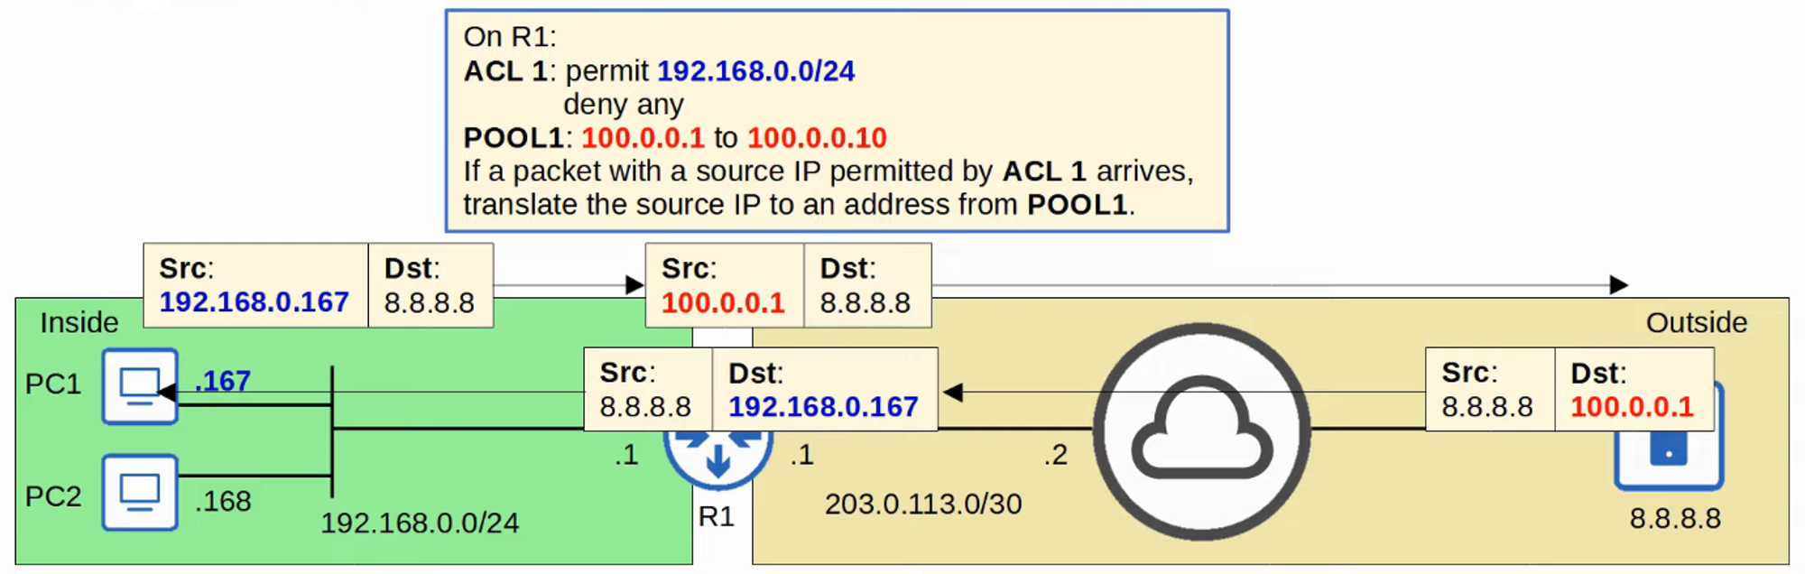

* Although dynamically assigned, the mappings remain **one-to-one** (one **inside local IP address** per **inside global IP address**).
* If there are **not enough inside global IP addresses available**, it is called **NAT pool exhaustion**:
  + If a packet from another **inside host** arrives and needs NAT, but there are **no available addresses**, the **router will drop the packet**.
  + The **host will be unable to access outside networks** until an **inside global IP address** becomes available.
  + **Dynamic NAT entries** will **time out automatically** if unused or can be **cleared manually**.

### **NAT Pool Exhaustion**

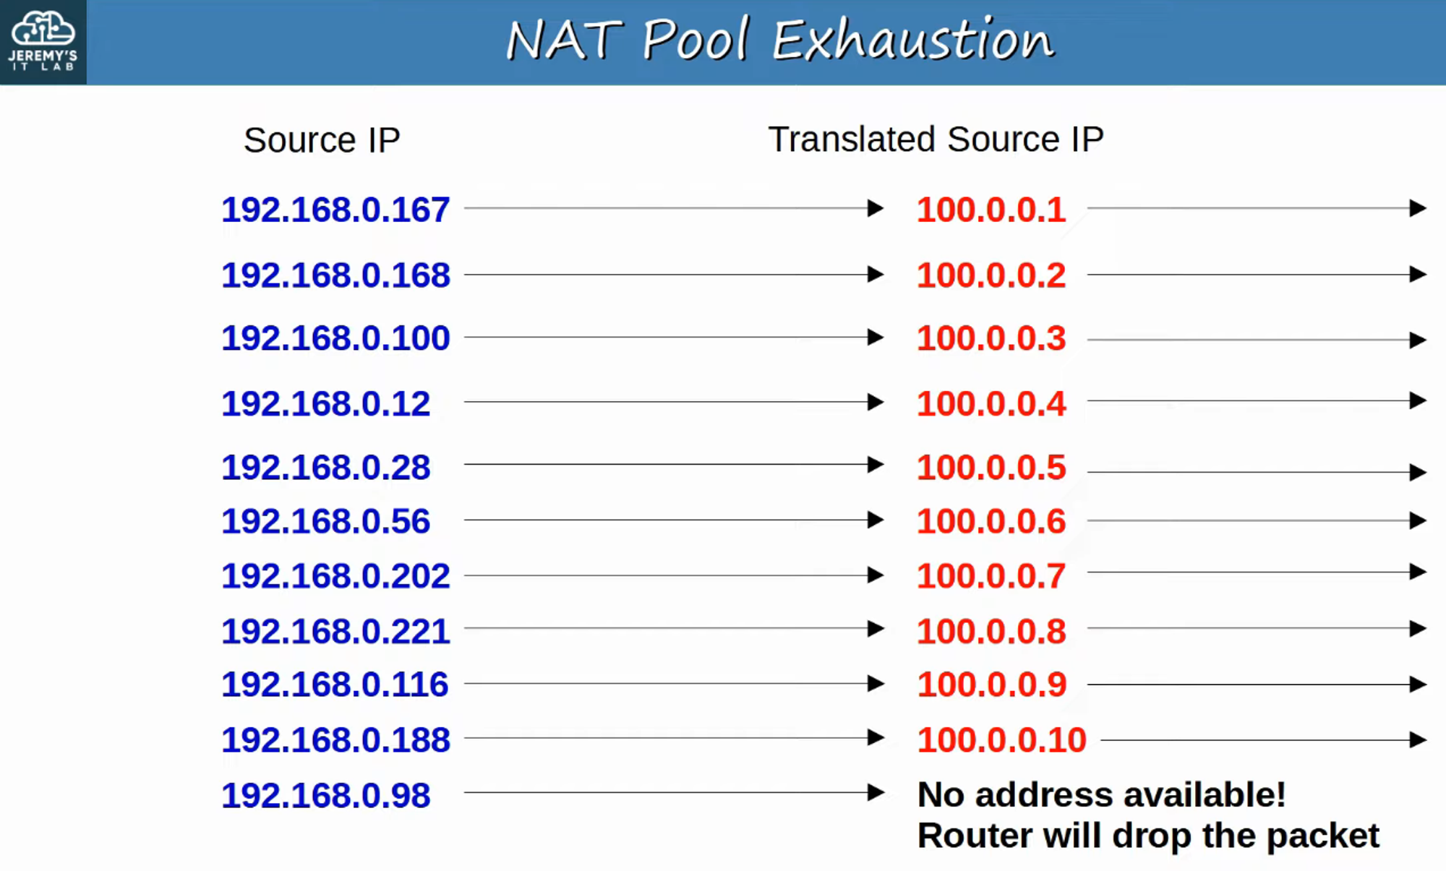

**192.168.0.167 times out, and 192.168.0.98 is assigned its translated source IP.**

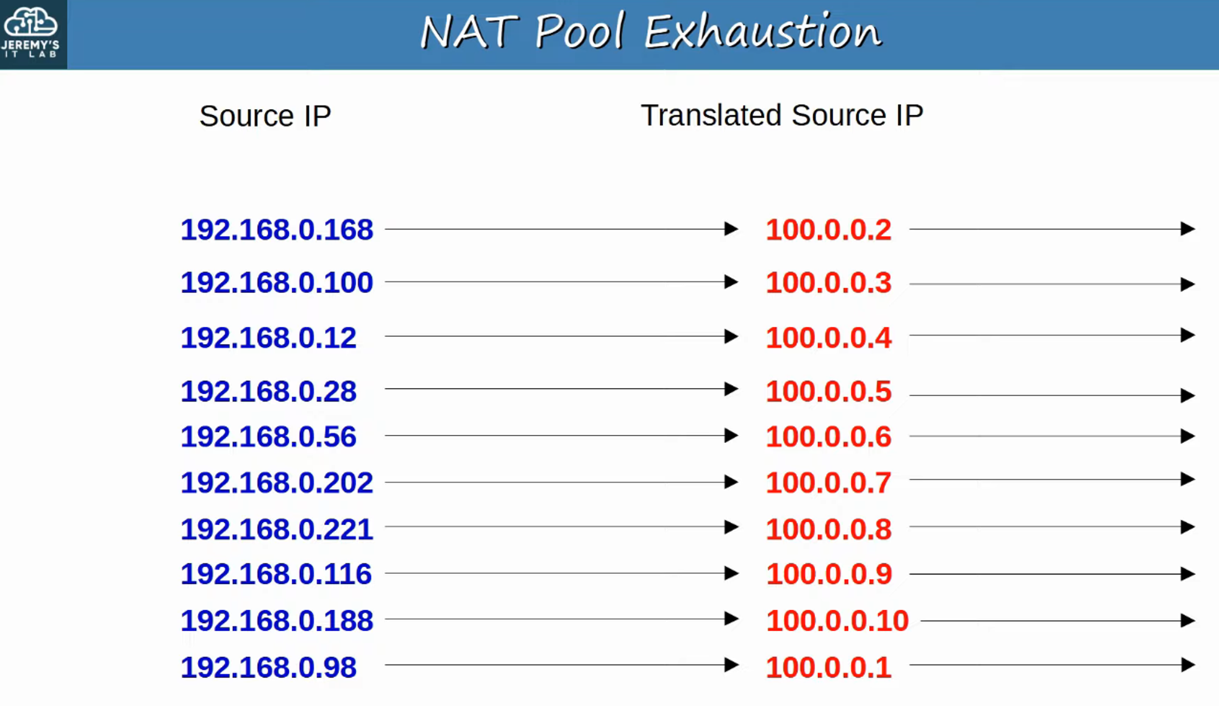

### **Dynamic NAT Configuration**

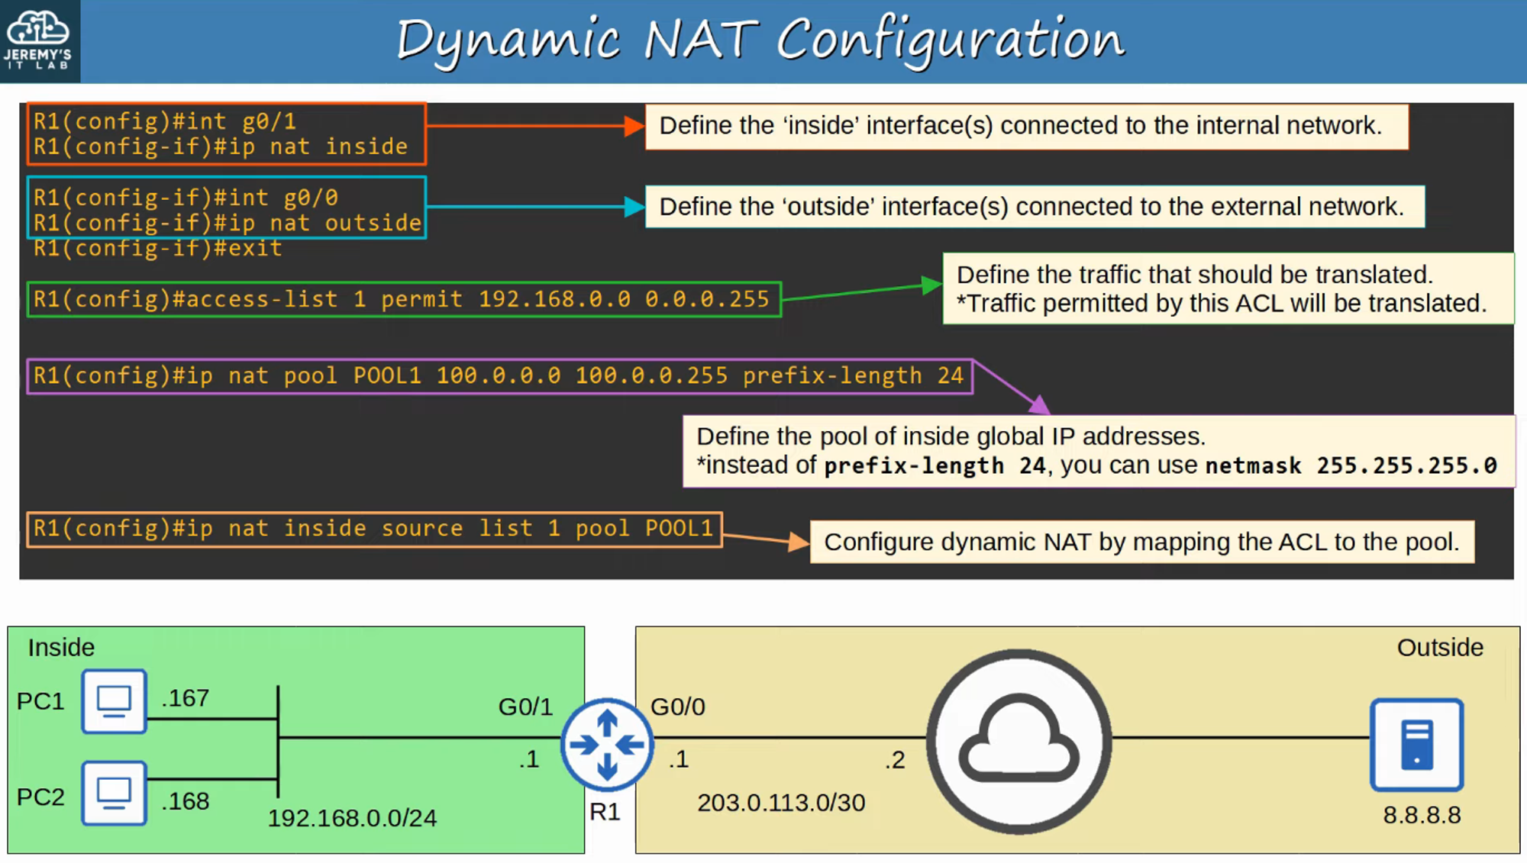

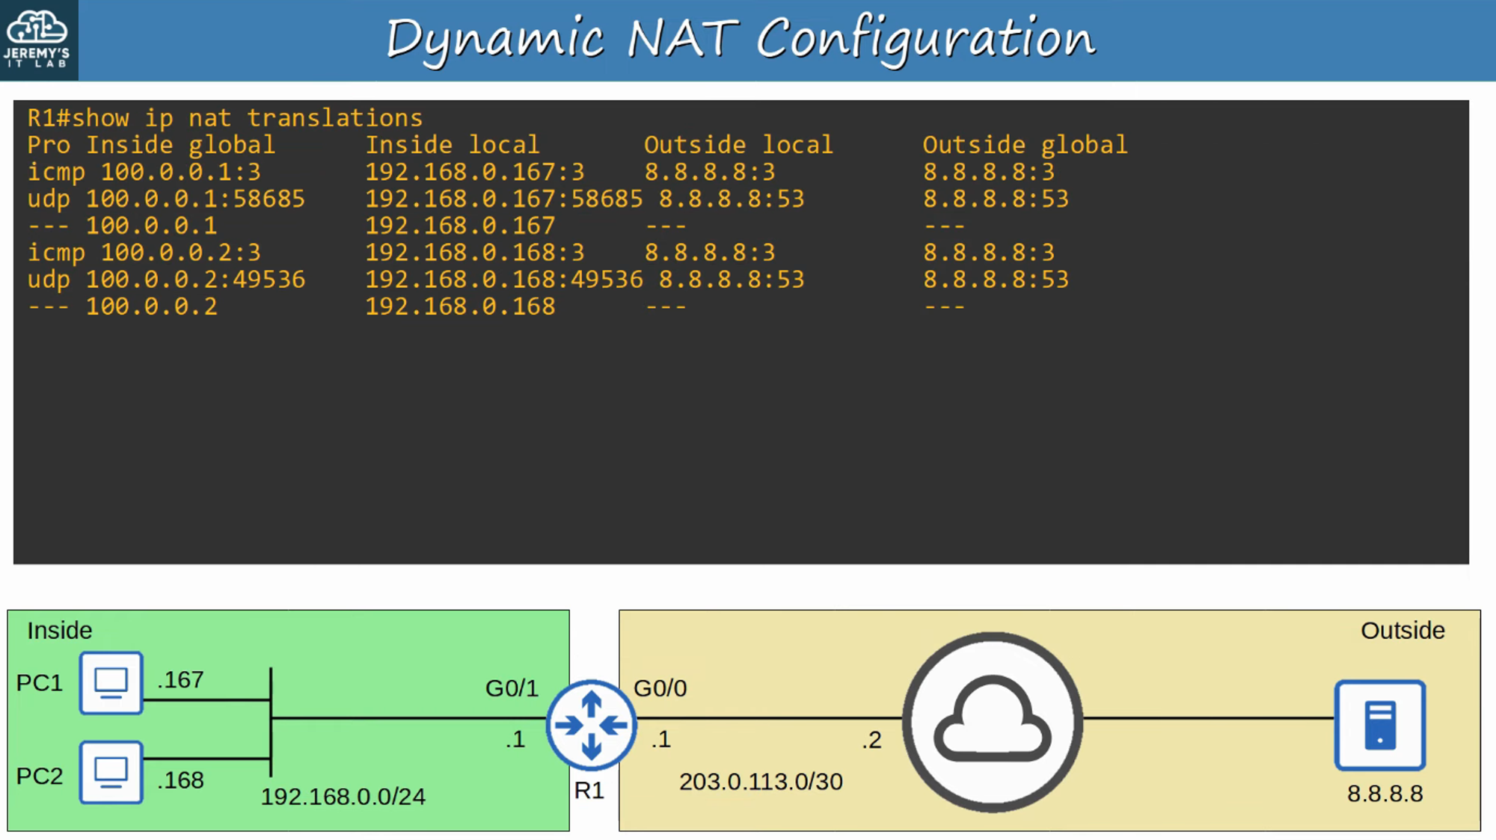

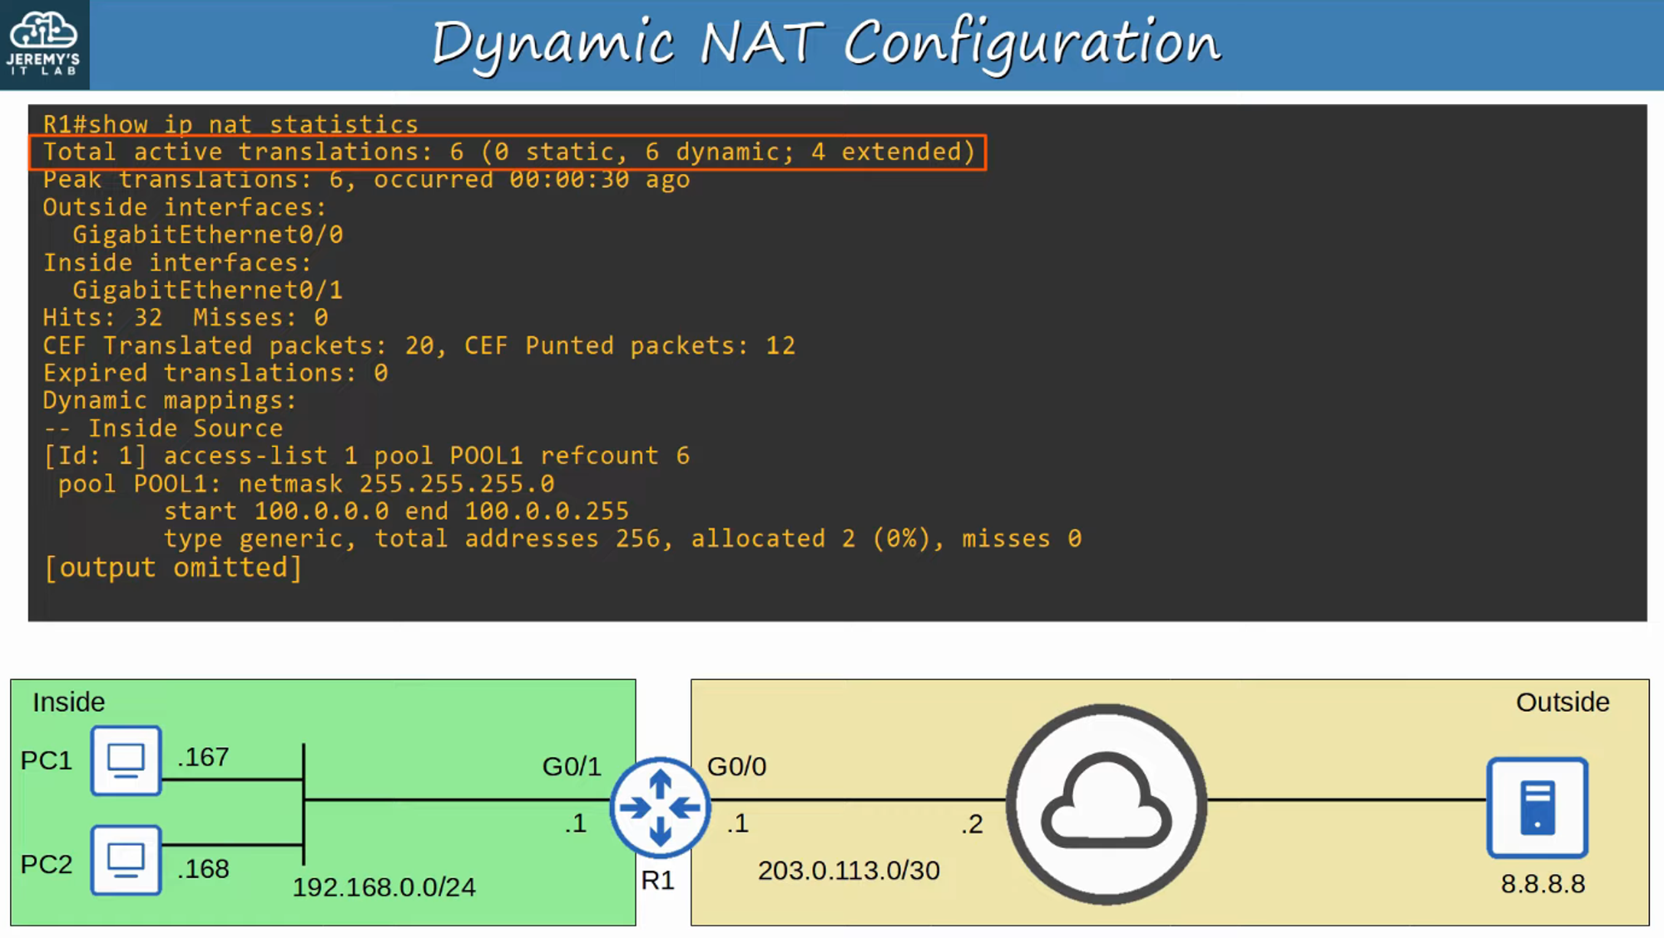

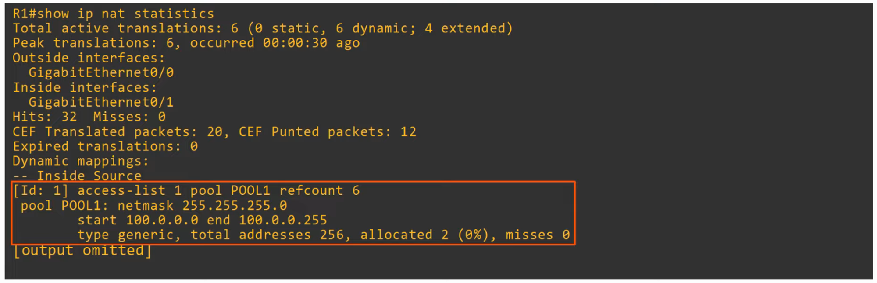

## **Dynamic PAT (NAT Overload)**

* **PAT (NAT Overload)** translates **both** the **IP address** and the **port number** (if necessary).
* By using a unique **port number** for each communication flow, a **single public IP address** can be used by **many different internal hosts**.
  + **TCP/UDP Port numbers** are **16 bits**, allowing for **over 65,000 available port numbers**.
* The **router** keeps track of **which inside local address** is using **which inside global address and port**.

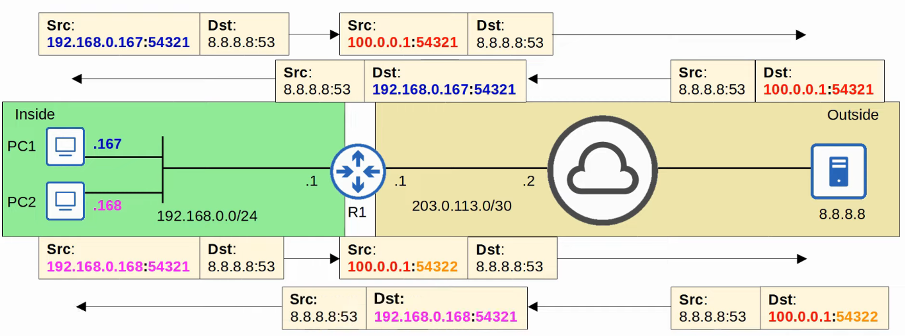

### **PAT Configuration (Pool)**

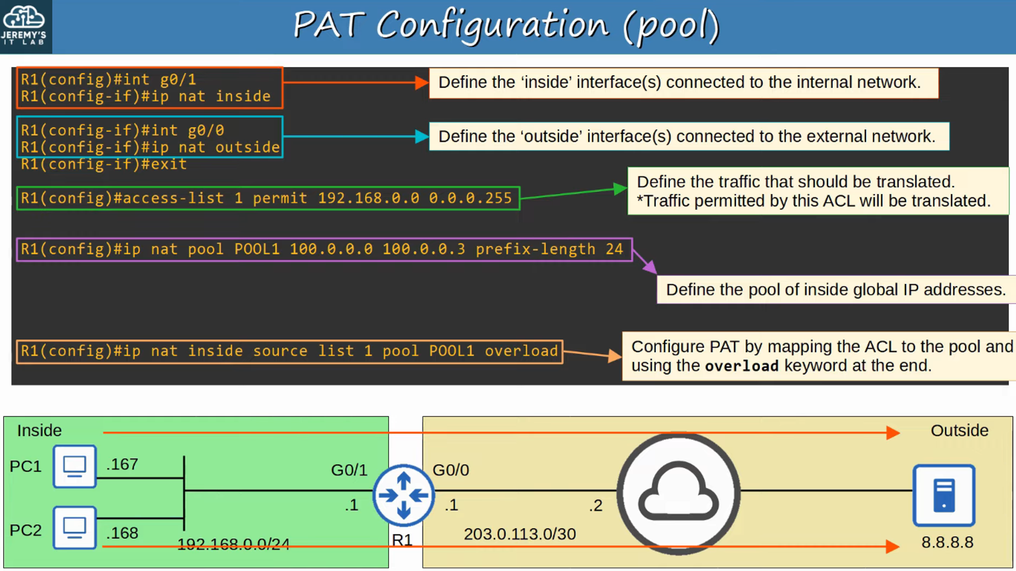

#### **Show PAT Translations**

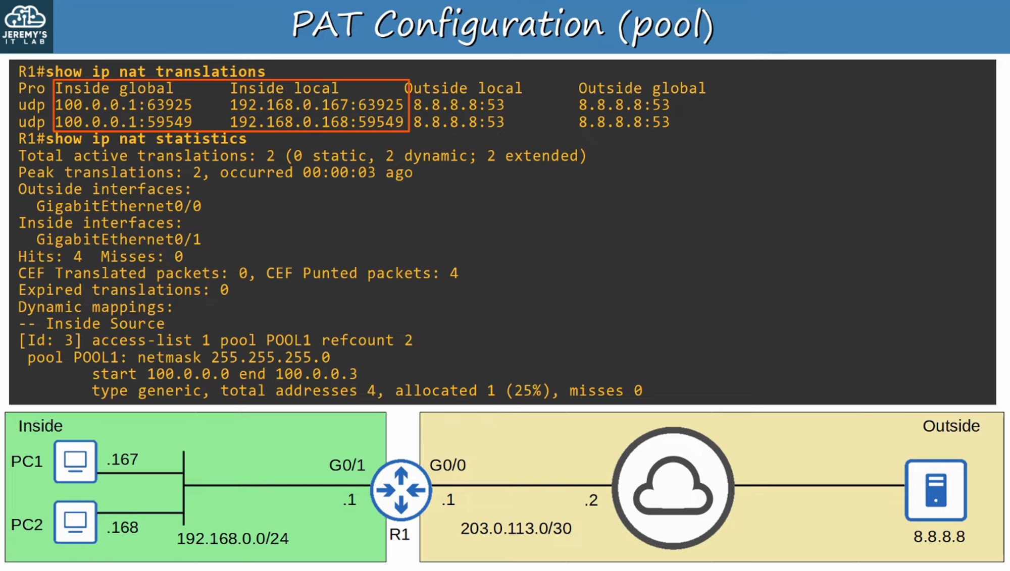

### **PAT Configuration (Interface) -> More commonly used**

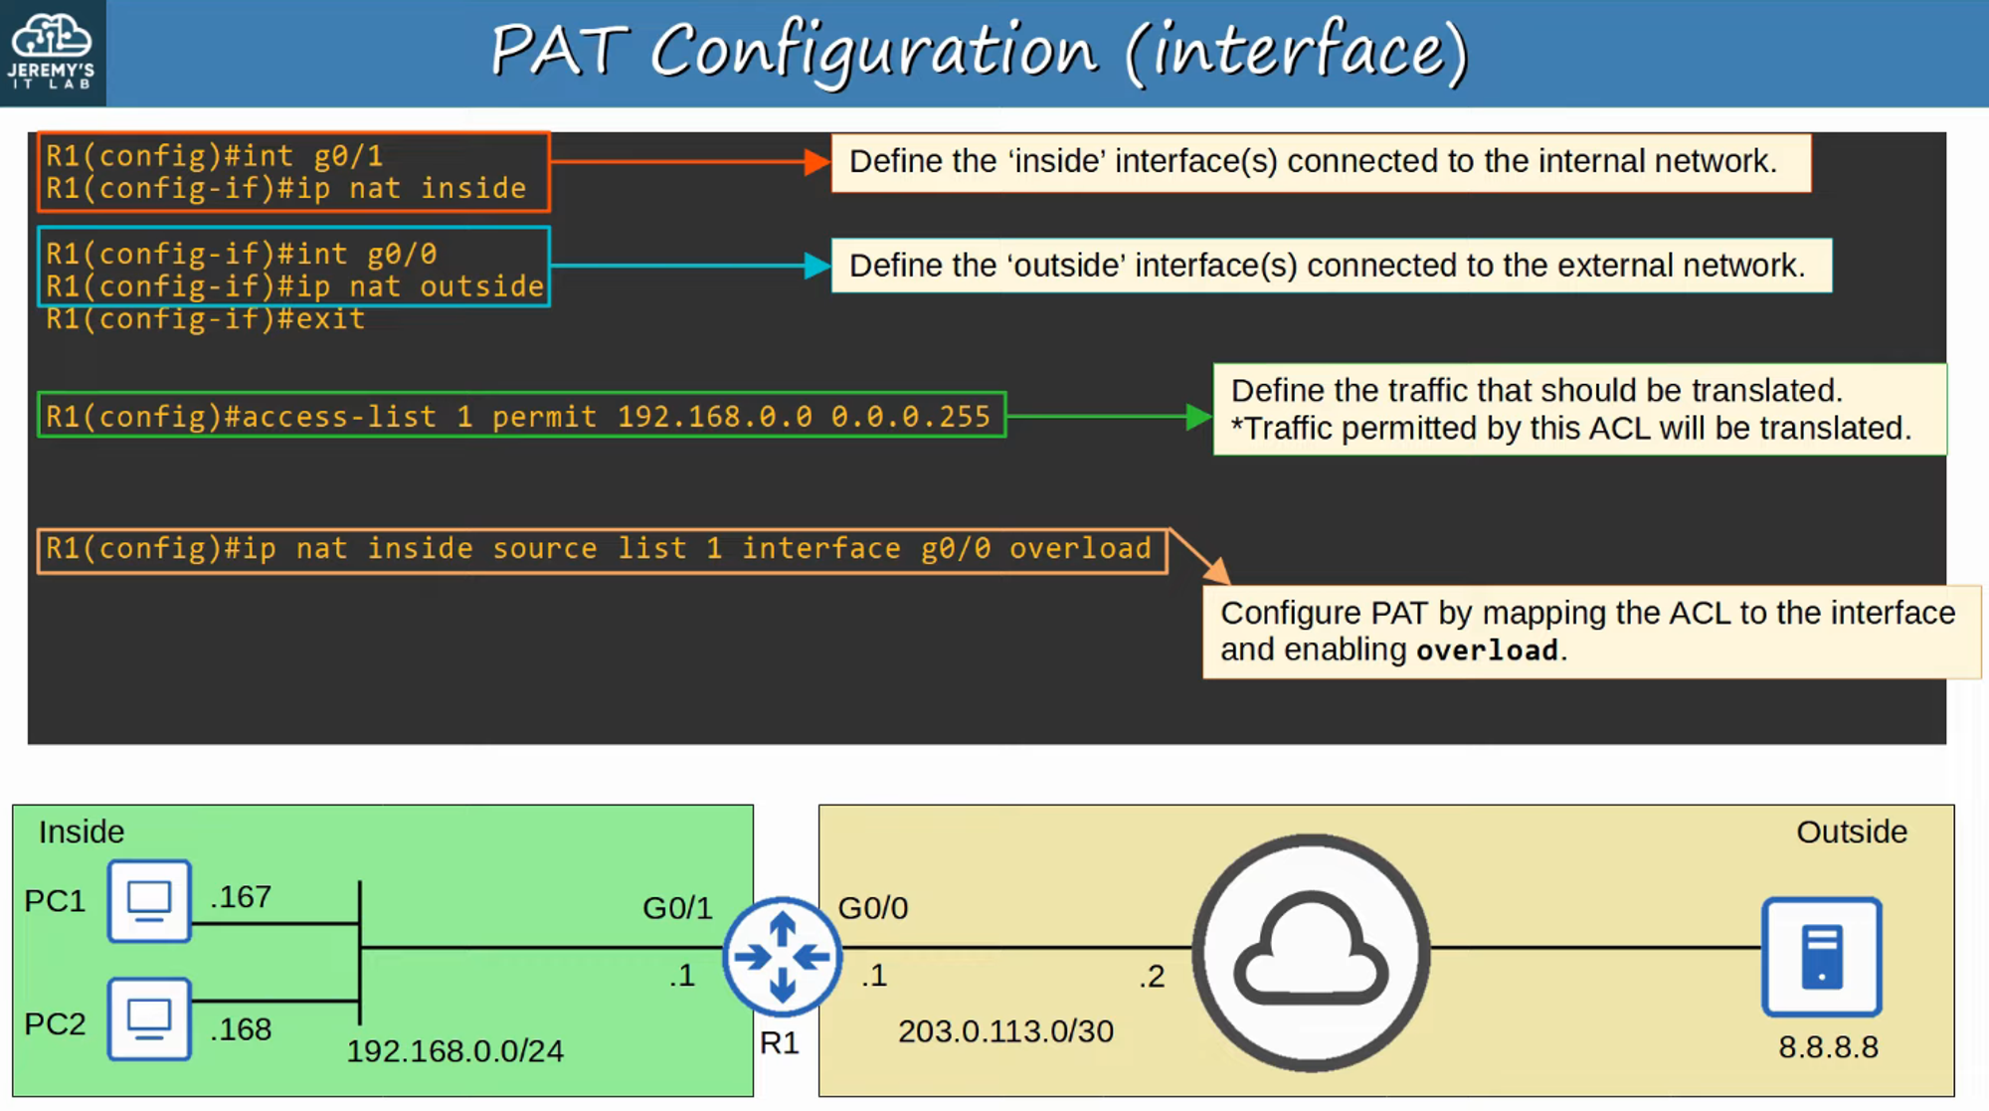

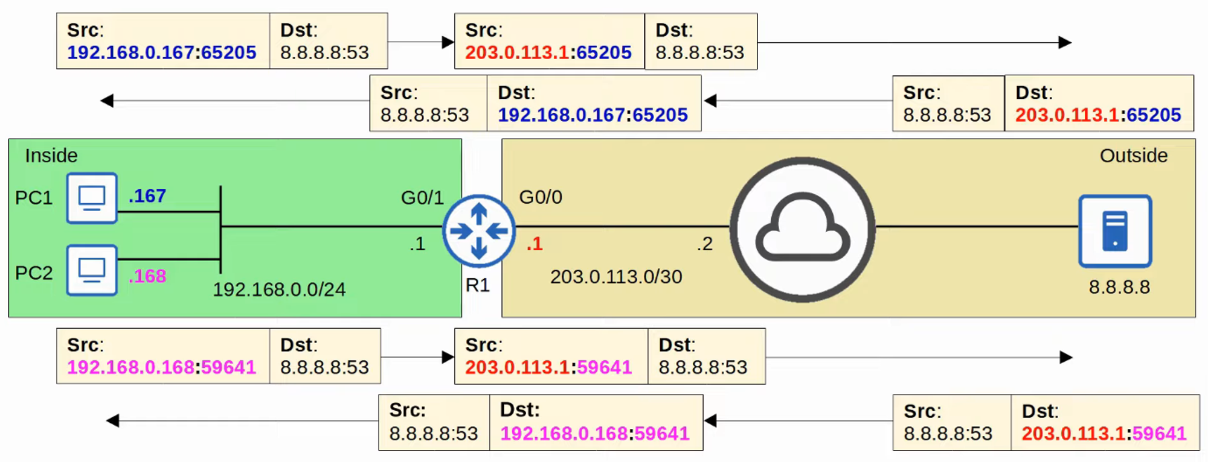

#### **Show PAT Translations**

show ip nat translations

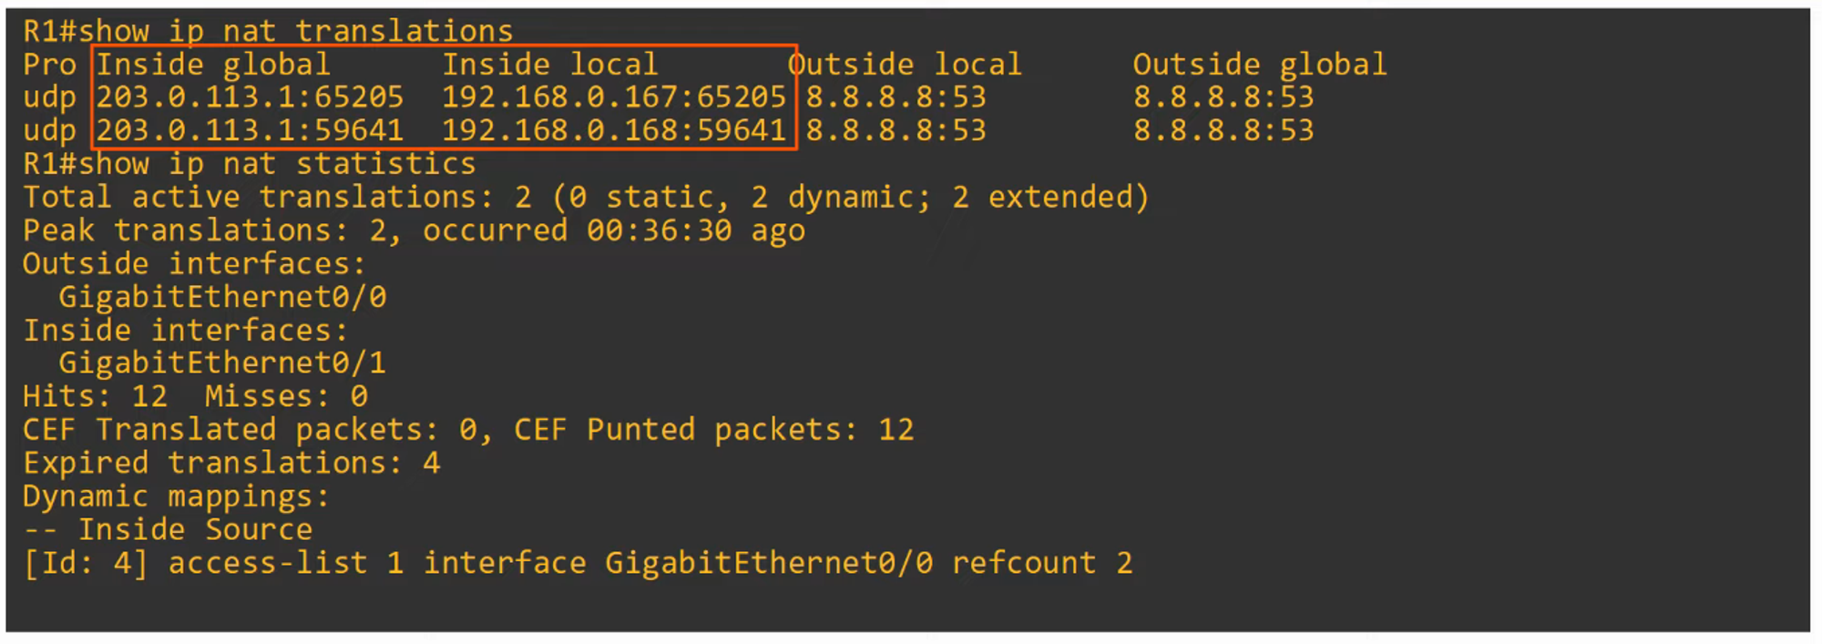

## **Command Review**

